Year 6 Newsletter #4 2010
Important Dates
Fri 26th Mar
School Athletics Carnival – confirmed

Mon 29th Mar
Boy/Girl Soccer Selections – Cootamundra

Tues 30th Mar
Rugby League Selections - Harden

Wed 31st Mar
PSSA Touch Knockout Boys/Girls - Temora
K-2/3-6 Disco

Thurs 1st Apr
Last Day of Term One

Sun 18th Apr (during school holidays)
Gold Trail Event – Great intro to Term Two Unit

Tues 20th Apr
Students begin Term Two

Mon 26th Apr
ANZAC Day – Public Holiday

Sat 1st May
MPS Working Bee

Thurs 6th May
Mother’s Day Stall

Fri 7th May
P & C Cake Stall

Mon 14th Jun
Queen’s Birthday – Public Holiday

Wed 23rd Jun – Fri 25th Jun
Year 5/6 Camp – Ballarat

Dear Parents,
Wow! Well, I think we all got a touch of the Ului cyclone this term! It’s hard to believe that we have just three terms left before high school!

Year Six have been very busy and for many of them, sporting commitments will mean a lot of travel in the final days of term one. I would like to wish competitors good luck for the soccer trials and rugby league selections. I am also very excited about the upcoming PSSA Touch Knockout which will be played in Temora next Wednesday. If your child is attending, please ensure notes are returned on time so as transport can be arranged.

As part of the school welfare program we have established a buddy system with the 2010 Kinder Class. I have thoroughly enjoyed observing Year 6 as they work together with their buddy on a variety of learning tasks. Students have demonstrated great leadership capabilities and it is great to see the responsible role-modelling taking place within the school. Year 6s are also learning a lot about patience and realising just how much they’ve achieved throughout their time at MPS.

In class we have been learning about report and exposition (persuasive) text types. Students have been publishing their work to be presented in a portfolio. We have also been learning about China; the similarities and differences between our countries and about the successes of famous Chinese Australians. During Circle Time (PDHPE discussion program) students have been discussing what life might be like as a Chinese Australian in our local community.

Next term we will be learning about Australian History with a focus on the gold rush period. Students will also be learning under the guidance of our visitor, Danielle Schneider who will be teaching the class for a two week period as a component for her teaching internship. Danielle has been working with small groups and taking short sessions and will be with MPS for eight weeks in total.

Please take a moment to read the back of this letter and send in the form.

I’d like to wish everyone a safe and Happy Easter break! I hope each and every one of you gets some time to put your feet up!

Thanks again to parents for their continued support and willingness to help out within the school.

Until next term,

Letitia/Miss O’C

Male? Interesting? We want you!
Year 6 are looking for one special man to become a part of their lives! With all of the femal role-models that surround them at school, we think it would be great to hear what life is like for a man! We are looking for someone who would be willing to pop in to the classroom once/twice a term to chat to students about life and give students the opportunity to ask questions and learn more about the world from a male perspective (like, how do they learn the skills to cook!!!).
Having positive female and male role models is an essential aspect in successful child development. If you think you or someone you know might be willing to come and say G’day to our class, please complete the short form below. Thanks, Year 6 and Miss O’C

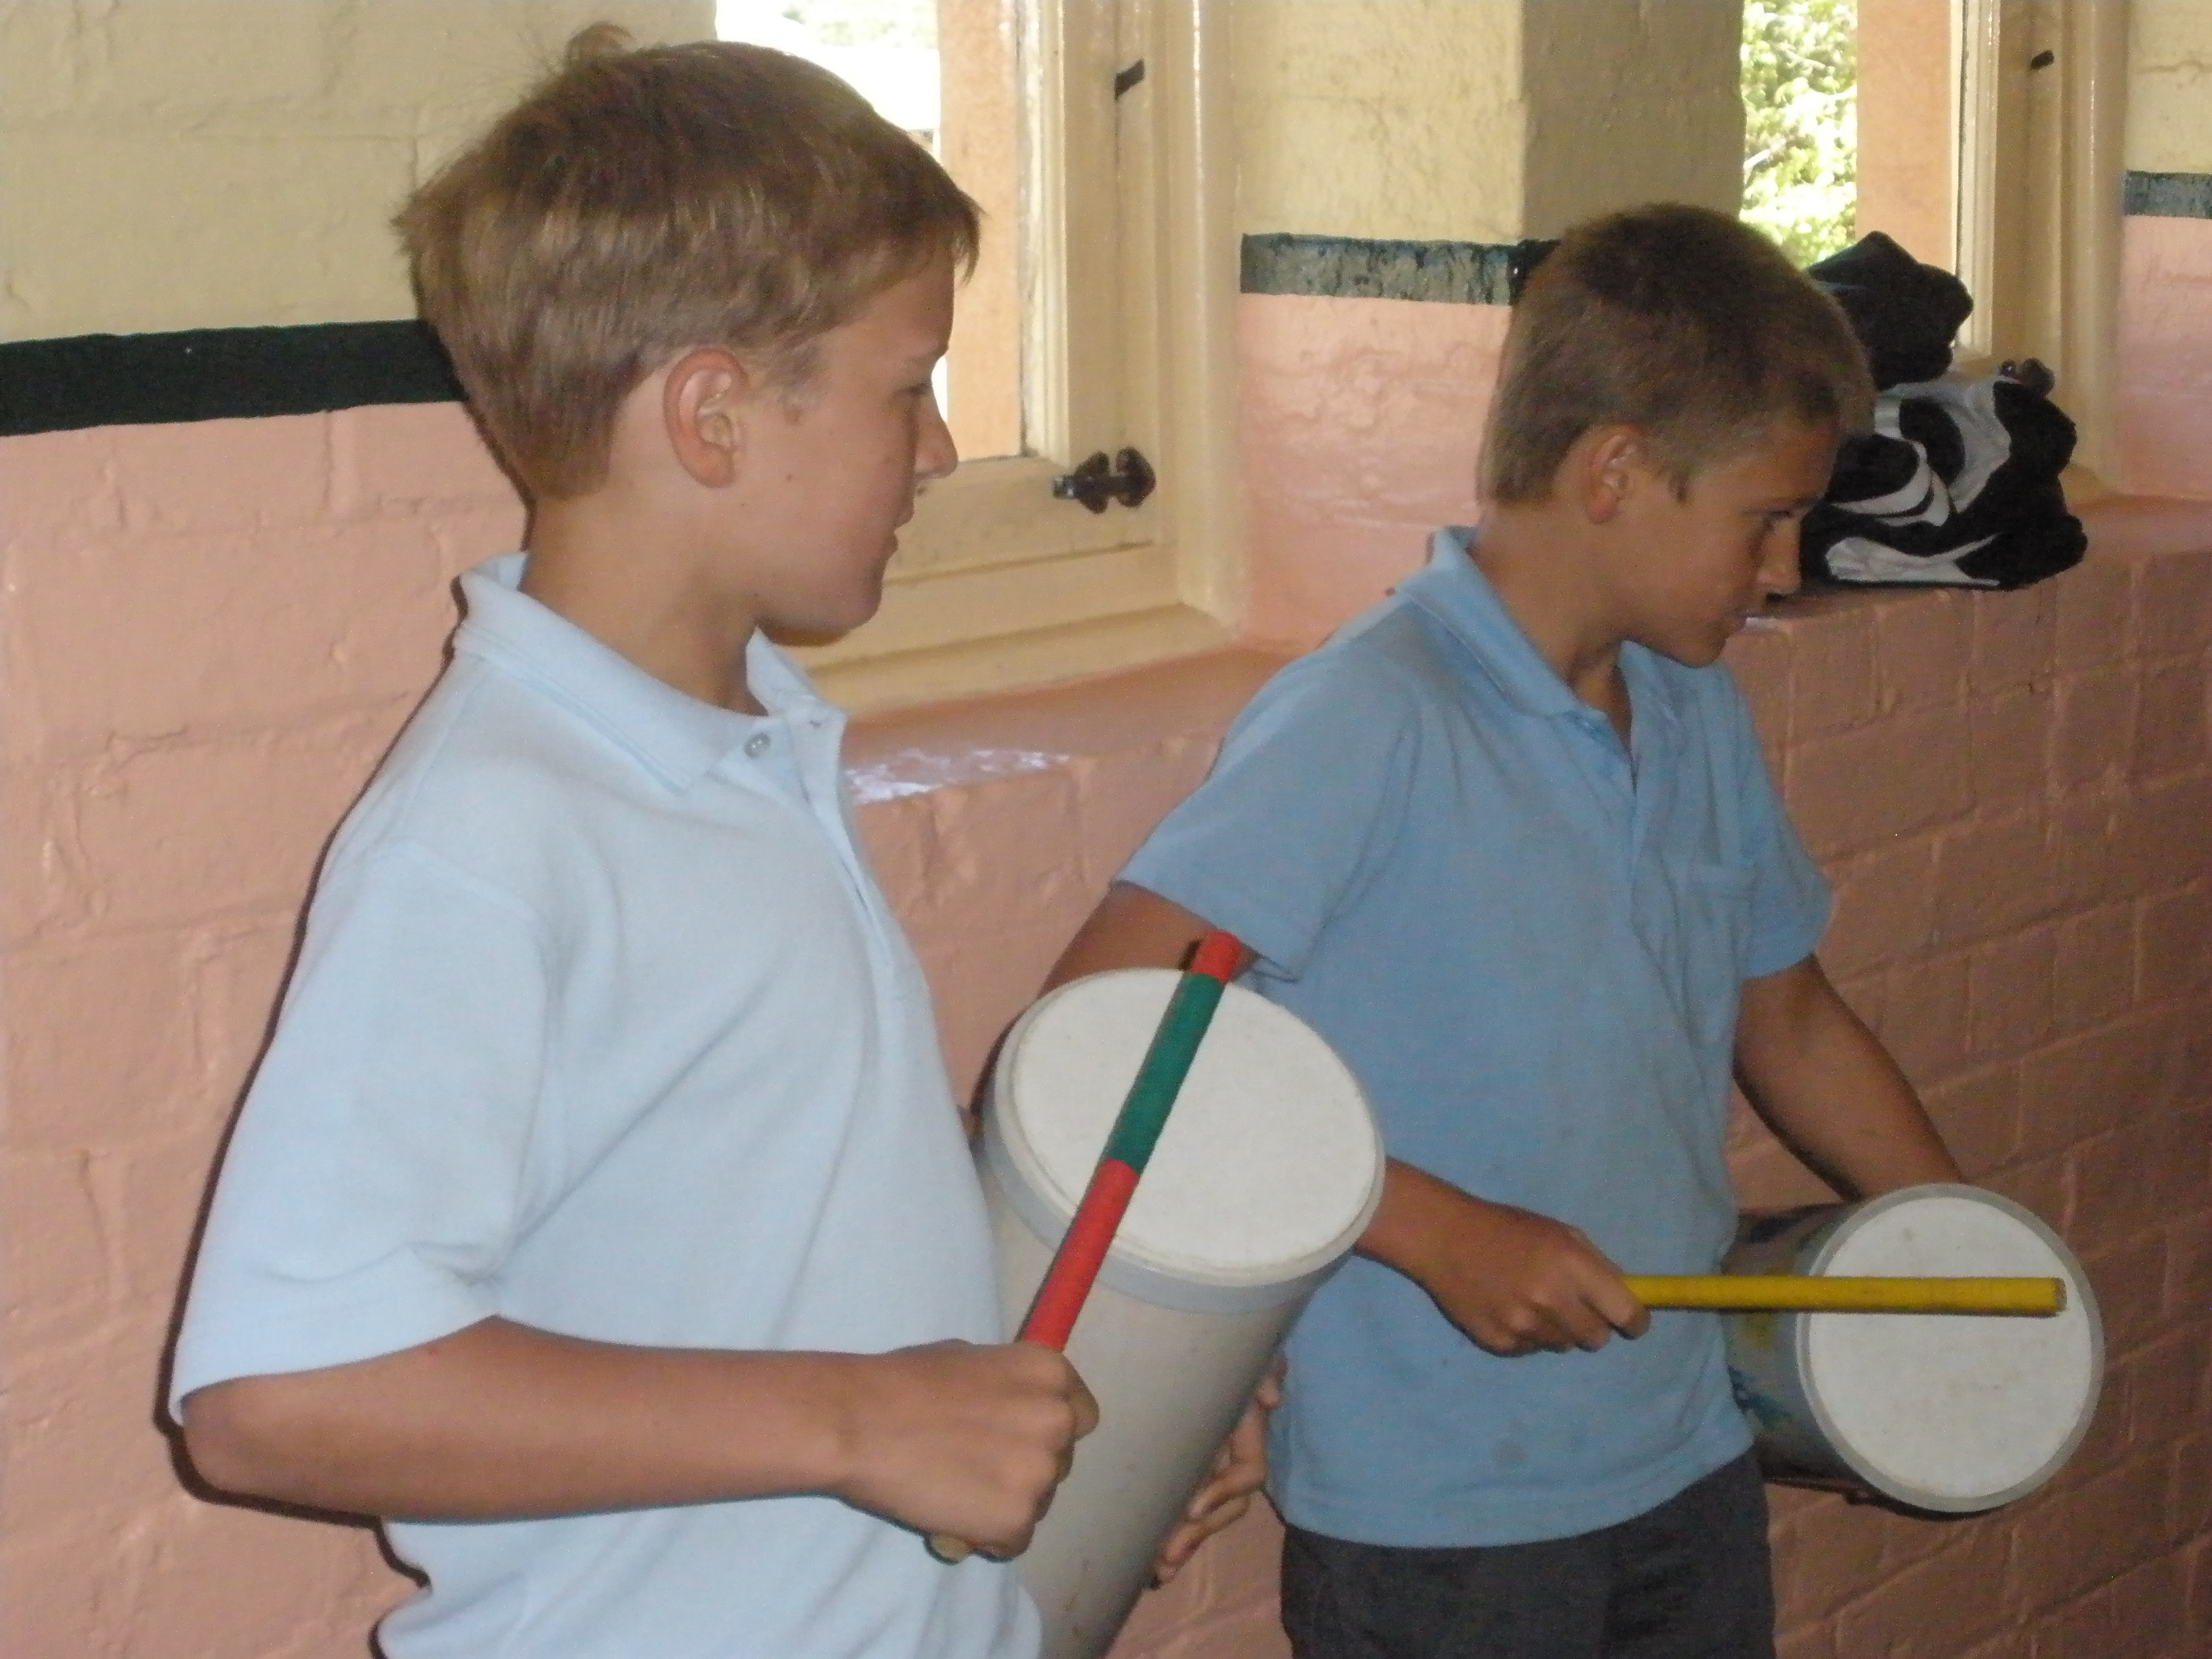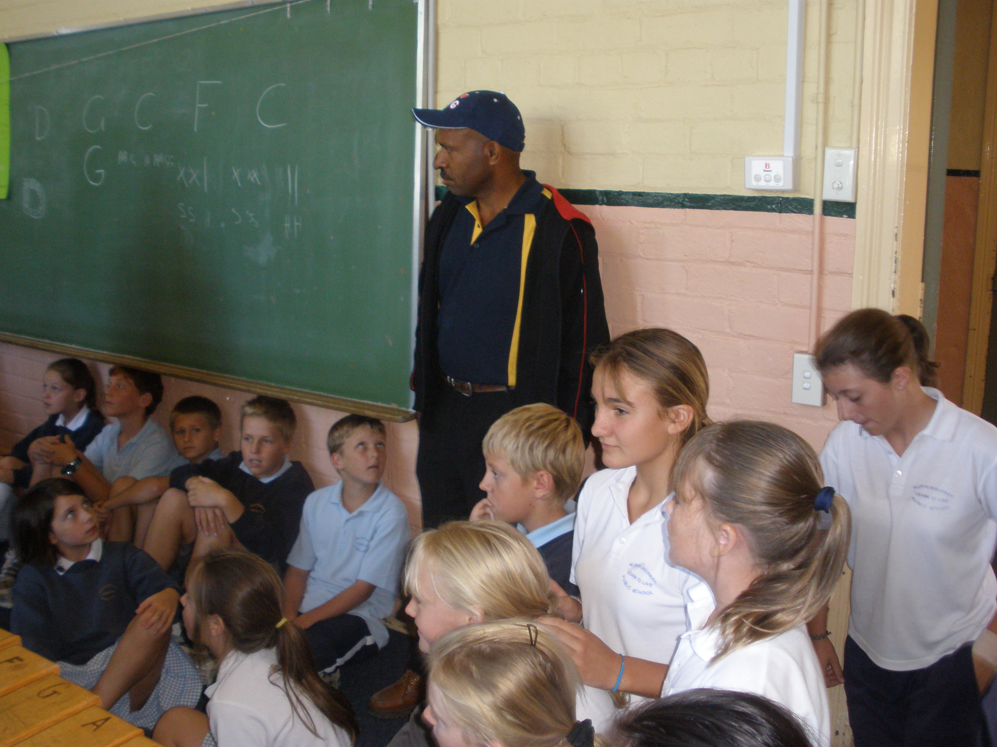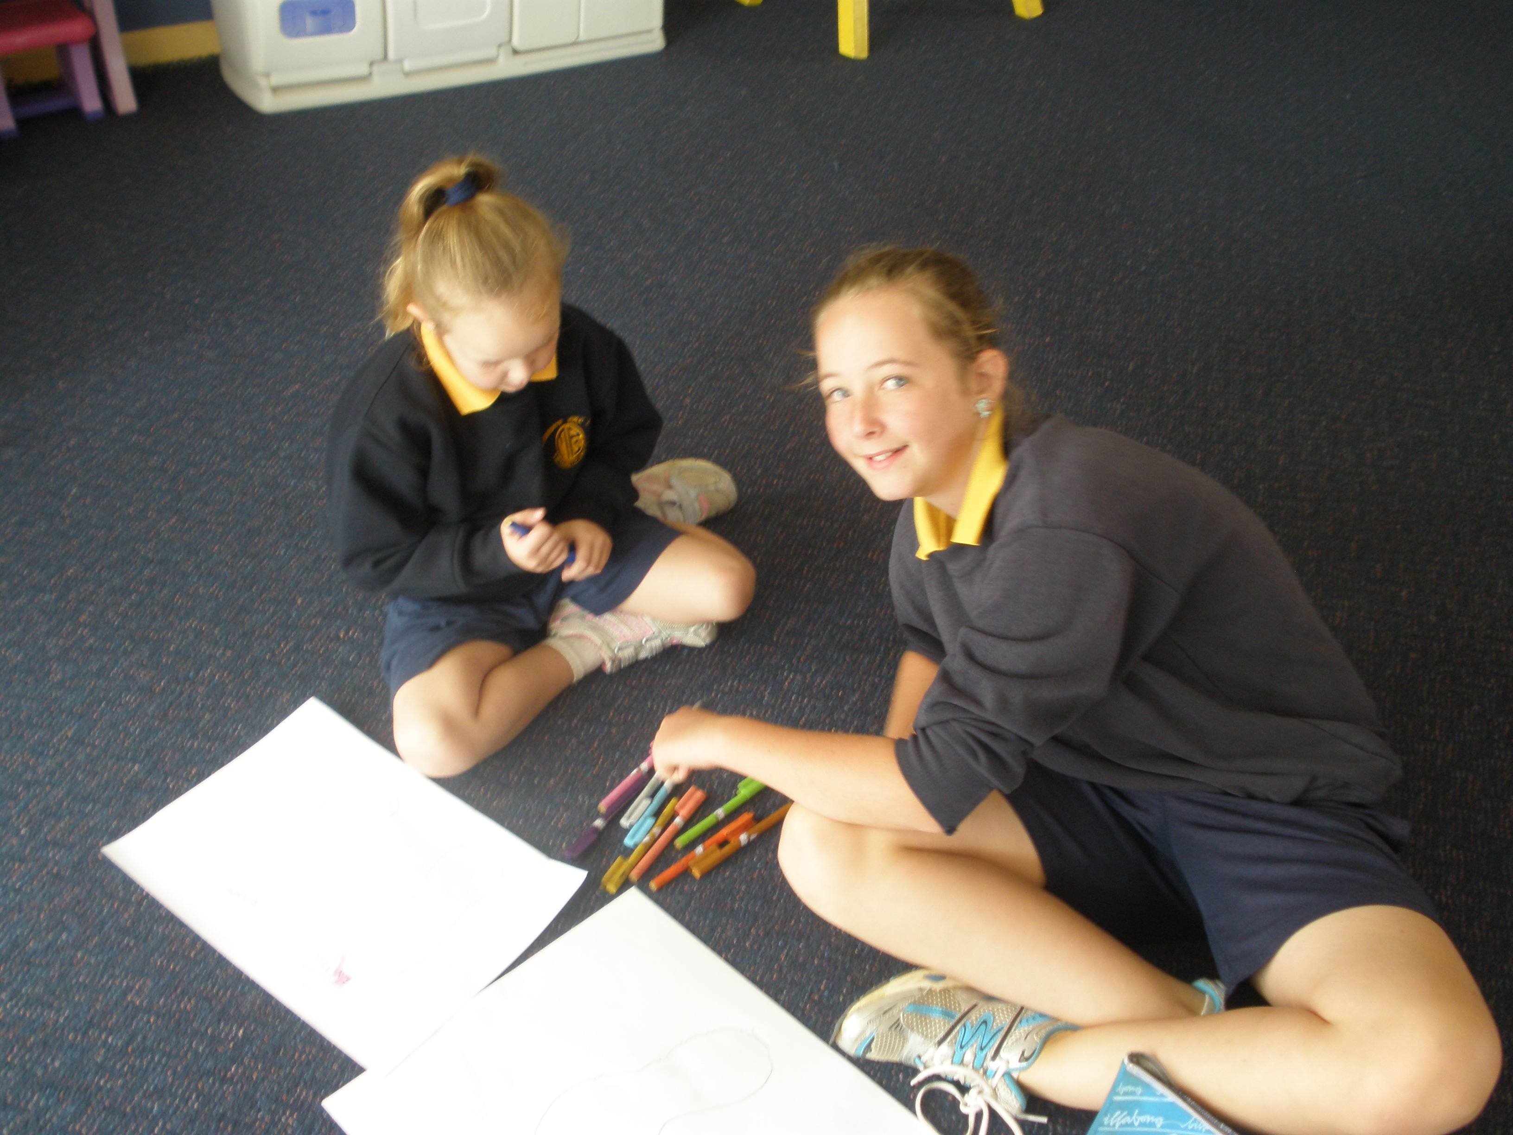
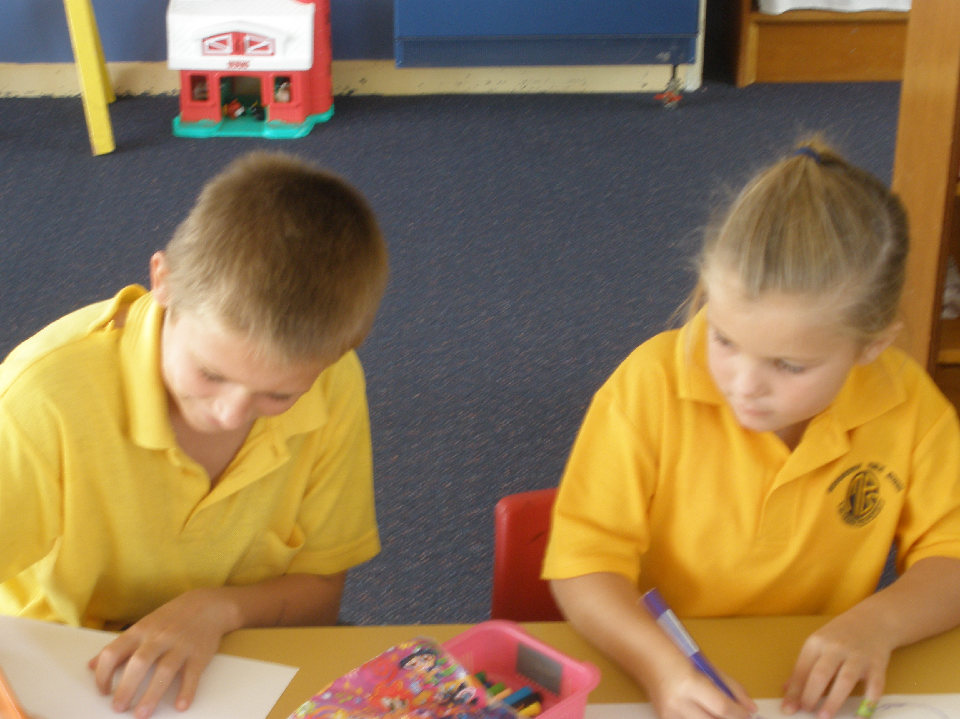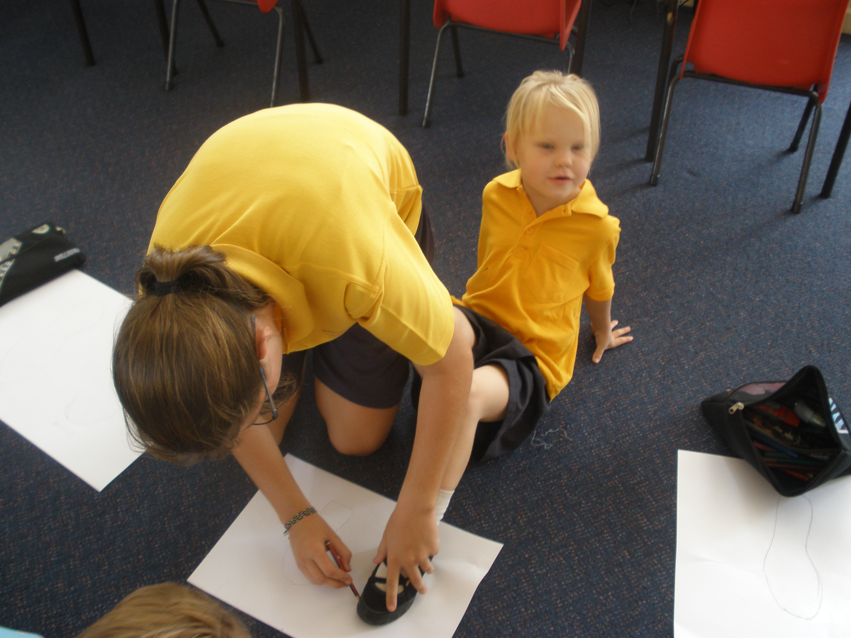
Year 6 Helpers
We are looking again for any parents who would be interested in coming in to help with reading, literacy/numeracy groups.
I ___________________________________ would be interested in coming in to help.
Day: ________________________ Time: ______________ Passion: ____________________

Happy Birthday
Jeffrey
Say G’Day!!
I ___________________________________ would be interested in becoming Year Six’s Big Mate.
Afternoon per term (please circle): 1 2
Passion: ____________________



